Monte Carlo method using random variation
Preston Heen
3/30/2020
Introduction
In this lab I wanted to model the one-seed juniper (Juniperus monosperma) using a Categorical and Regression Tree (CART) modelling method. The CART model is easy to interpret the classification tree and understand. We are applying the models to all fields to find new patterns (Nijhawan 2018). The goal of this lab was to estimate the uncertainty in the measured values and the predictor variables.

Methods
In this lab I am researching the one-seed juniper (Juniperus monosperma), and it has a native range of western North America. This was downloaded from the Forest Inventory Analysis plots. The predictor variables I used were precipitation, solar radiation, and wind to predict the max height. The goal of this lab was to use the Monte Carlo modelling method to estimate the uncertainty of the measured values and predictor variables in my model.
Table 1. Model Parameters
Model Run | Gamma Values | Model Parameters
1 | $$1≤10$$ | .2
2 | $$-10≤10$$ | .1
3 | $$-50≤50$$ | .2

Results
The results of this lab is a CART model and estimated uncertainty using the Monte Carlo method. I ran the model three times with different amounts of noise. I found the statistics of the model runs and the summaries of the AIC values and standard deviations values.
Table 2. Noise injected
Model Run | Noise Injection
1 | 900
2 | 500
3 | 500

Table 3. Summary of AIC
Model Run | Minimum | 1st quantile | Median | Mean | 3rd quantile | Maximum
1 | 20948 | 21106 | 21159 | 21154 | 21206 | 21378
2 | 20943 | 21114 | 21166 | 21160 | 21211 | 21321
3 | 20943 | 21108 | 21157 | 21153 | 21203 | 21355
Table 4. Summary of Standard Deviations
Model Run | Minimum | 1st quantile | Median | Mean | 3rd quantile | Maximum
1 | 4.245 | 4.516 | 4.585 | 4.591 | 4.662 | 4.891
2 | 4.317 | 4.506 | 4.576 | 4.582 | 4.656 | 4.901
3 | 4.265 | 4.517 | 4.585 | 4.593 | 4.659 | 4.893
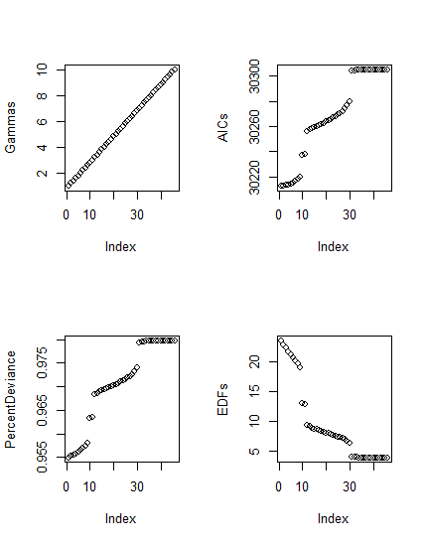
Figure 1 Model 1 statistics
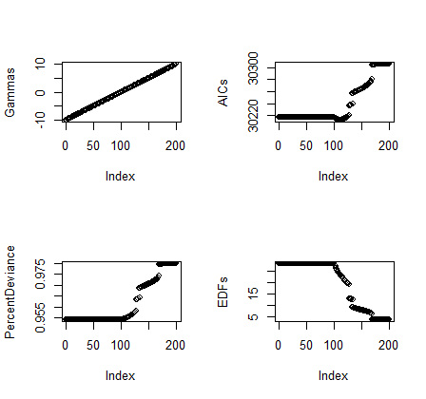
Figure 2. Model 2 statistics
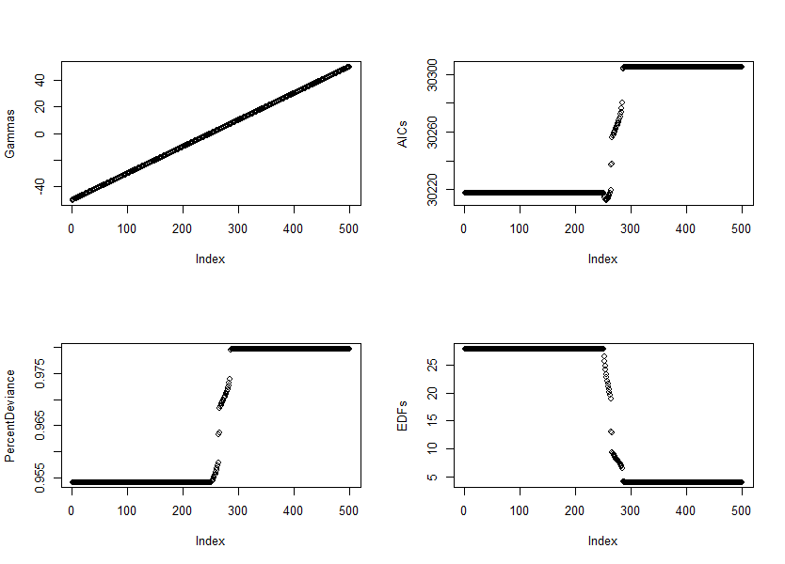
Figure 3. Model 3 statistics

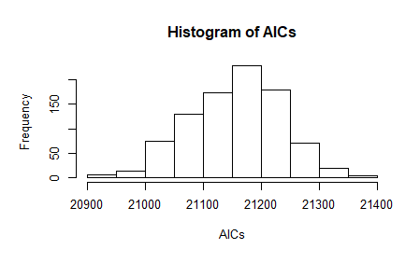
Figure 3. Model 1 Monte Carlo statistics
Discussion
Since raster images can not capture all features in a single pixel, we can estimate the uncertainty of the measured values and predictor variables. Data is interpolated over areas where it can not be representative of the whole area.

References
Nijhawan, V. K., Madan, M., & Dave, M. (2018, August 31). An Analytical Implementation of CART Using
RStudio for Churn Prediction. Retrieved from https://link.springer.com/chapter/10.1007/978-
981-13-0586-3_11

